UNIVERSITY INSTITUTE OF COMPUTING

PROJECT REPORT
ON
Hospital Management System
OBJECT ORIENTED PROGRAMMING
25CAH-201

SUBMITED BY:

Name : KANAK RANA UID : 25BCD10104

Branch : BCA(DATA SCIENCE) Group: A Section:25BCD2

Semester : 3

SUBMITED TO:

Name : MR. JITENDRA KUMAR D.O.SUBMITION : 29-10-2026

Desigination: PROFESSOR
Sign:____________________

Project Report: Project Title
1. Introduction
A Hospital Management System is a software application that organizes essential hospital information such as patient and doctor records. This project is a menu-driven C++ console application developed using Object-Oriented Programming (OOP). It allows hospital staff to register patients and doctors, view stored records, and search for a patient by ID. The application demonstrates abstraction, inheritance, runtime polymorphism, and encapsulation.
2. Problem Statement
Manual patient and doctor registers are time-consuming to maintain and difficult to search. Duplicate identifiers and inconsistent entries may cause confusion. A simple digital system can centralize basic records, improve retrieval, and provide a foundation for larger hospital software.
3. Objectives
Create a menu-driven hospital record application in C++.
Store patient ID, name, age, and disease.
Store doctor ID, name, and specialization.
Display patient and doctor records and search patients by ID.
Demonstrate inheritance, abstraction, encapsulation, and runtime polymorphism.
Handle invalid menu input and prevent duplicate IDs within each record type.
4. Tools and Technologies
Programming language: C++17
Compiler: g++ / MinGW / Code::Blocks / Visual Studio
Interface: Console (text-based menu)
Libraries: iostream, vector, memory, string, limits
Storage: In-memory vectors (records reset when the program closes)
5. OOP Concepts Used
5.1 Abstraction
Person is an abstract base class because it declares the pure virtual function display() = 0. A Person object cannot be instantiated directly. Derived classes provide the implementation.
5.2 Inheritance
Patient and Doctor publicly inherit from Person. They reuse the common ID and name attributes and define their own specialized fields.
5.3 Runtime Polymorphism
display() is virtual in Person and overridden in Patient and Doctor. Calling display() through a Person reference executes the appropriate derived-class method at runtime.
5.4 Encapsulation
The Person class keeps common data protected; specialized fields in Patient and Doctor are private by default. Operations are exposed through public member functions.
6. Class Design
Person (abstract): protected id, name; public getId(), pure virtual display(), virtual destructor.
Patient : Person — private age, disease; overrides display().
Doctor : Person — private specialization; overrides display().
Hospital — owns vectors of Patient and Doctor objects; provides add, view, and search operations.
Inheritance diagram:
Person (abstract)
/ \
Patient Doctor
Hospital manages Patient and Doctor collections.
7. Modules
Patient Registration: accepts details and checks for duplicate patient IDs.
Doctor Registration: accepts details and checks for duplicate doctor IDs.
Patient Listing: prints all registered patients.
Doctor Listing: prints all registered doctors.
Patient Search: locates a patient using their ID.
Input and Exit: validates numeric input and exits safely.
8. Algorithm
Start program and create a Hospital object.
Display the main menu.
Read a valid integer choice.
Execute the selected add, view, or search operation.
Return to the menu until the user selects Exit.
End the program.
9. Source Code
The complete compilable C++17 source code is supplied separately as hospital_management.cpp and is also reproduced below.
#include <iostream>
#include <vector>
#include <memory>
#include <string>
#include <limits>
using namespace std;

// Abstract base class: abstraction and encapsulation
class Person {
protected:
int id;
string name;
public:
Person(int i, string n) : id(i), name(n) {}
virtual void display() const = 0; // Pure virtual function
virtual ~Person() = default;
int getId() const { return id; }
};

// Inheritance: Patient is a Person
class Patient : public Person {
int age;
string disease;
public:
Patient(int i, string n, int a, string d)
: Person(i, n), age(a), disease(d) {}
void display() const override {
cout << "Patient ID: " << id << " | Name: " << name
<< " | Age: " << age << " | Disease: " << disease << '\n';
}
};

// Inheritance: Doctor is a Person
class Doctor : public Person {
string specialization;
public:
Doctor(int i, string n, string s)
: Person(i, n), specialization(s) {}
void display() const override {
cout << "Doctor ID: " << id << " | Name: " << name
<< " | Specialization: " << specialization << '\n';
}
};

class Hospital {
vector<unique_ptr<Patient>> patients;
vector<unique_ptr<Doctor>> doctors;
public:
void addPatient(int id, const string& name, int age, const string& disease) {
for (const auto& p : patients) {
if (p->getId() == id) { cout << "Patient ID already exists.\n"; return; }
}
patients.push_back(make_unique<Patient>(id, name, age, disease));
cout << "Patient added successfully.\n";
}
void addDoctor(int id, const string& name, const string& specialty) {
for (const auto& d : doctors) {
if (d->getId() == id) { cout << "Doctor ID already exists.\n"; return; }
}
doctors.push_back(make_unique<Doctor>(id, name, specialty));
cout << "Doctor added successfully.\n";
}
void showPatients() const {
if (patients.empty()) { cout << "No patients found.\n"; return; }
for (const auto& p : patients) {
const Person& person = *p; // Runtime polymorphism
person.display();
}
}
void showDoctors() const {
if (doctors.empty()) { cout << "No doctors found.\n"; return; }
for (const auto& d : doctors) {
const Person& person = *d; // Runtime polymorphism
person.display();
}
}
void searchPatient(int id) const {
for (const auto& p : patients) {
if (p->getId() == id) { p->display(); return; }
}
cout << "Patient not found.\n";
}
};

int readInt(const string& prompt) {
int value;
while (true) {
cout << prompt;
if (cin >> value) {
cin.ignore(numeric_limits<streamsize>::max(), '\n');
return value;
}
cout << "Please enter a valid number.\n";
cin.clear();
cin.ignore(numeric_limits<streamsize>::max(), '\n');
}
}
string readText(const string& prompt) {
string value;
do { cout << prompt; getline(cin, value); }
while (value.empty());
return value;
}
int main() {
Hospital hospital;
while (true) {
cout << "\n===== HOSPITAL MANAGEMENT SYSTEM =====\n"
<< "1. Add Patient\n2. Add Doctor\n3. View Patients\n"
<< "4. View Doctors\n5. Search Patient\n6. Exit\n";
int choice = readInt("Enter choice: ");
if (choice == 1) {
int id = readInt("Patient ID: ");
string name = readText("Patient name: ");
int age = readInt("Age: ");
if (age < 0 || age > 130) { cout << "Invalid age.\n"; continue; }
string disease = readText("Disease: ");
hospital.addPatient(id, name, age, disease);
} else if (choice == 2) {
int id = readInt("Doctor ID: ");
string name = readText("Doctor name: ");
string specialty = readText("Specialization: ");
hospital.addDoctor(id, name, specialty);
} else if (choice == 3) hospital.showPatients();
else if (choice == 4) hospital.showDoctors();
else if (choice == 5) hospital.searchPatient(readInt("Patient ID to search: "));
else if (choice == 6) { cout << "Thank you!\n"; break; }
else cout << "Invalid choice. Try again.\n";
}
}
10. Sample Output (Illustrative Console Run)
===== HOSPITAL MANAGEMENT SYSTEM =====
1. Add Patient
2. Add Doctor
3. View Patients
4. View Doctors
5. Search Patient
6. Exit
Enter choice: 1
Patient ID: 101
Patient name: Aman
Age: 24
Disease: Fever
Patient added successfully.
Enter choice: 2
Doctor ID: 201
Doctor name: Dr Sharma
Specialization: Cardiology
Doctor added successfully.
Enter choice: 3
Patient ID: 101 | Name: Aman | Age: 24 | Disease: Fever
Enter choice: 4
Doctor ID: 201 | Name: Dr Sharma | Specialization: Cardiology
Enter choice: 5
Patient ID to search: 101
Patient ID: 101 | Name: Aman | Age: 24 | Disease: Fever
Enter choice: 6
Thank you!
Note: These are formatted sample outputs, not screenshots. For a submission requiring screenshots, run the program and capture your own console screen.
10A. Actual Program Output Screenshots
The following screenshots were generated from actual executions of the C++ program with sample test inputs.
1 Main Menu
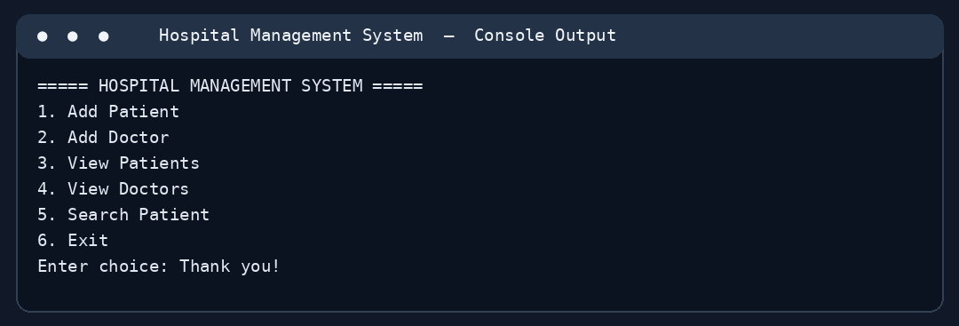
2 Add Patient
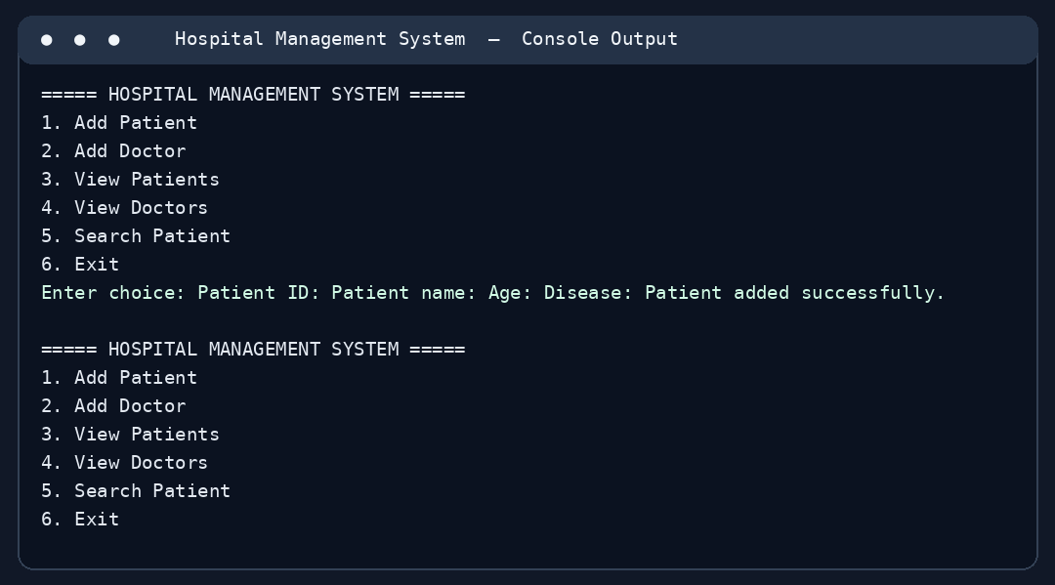
3 Add Doctor
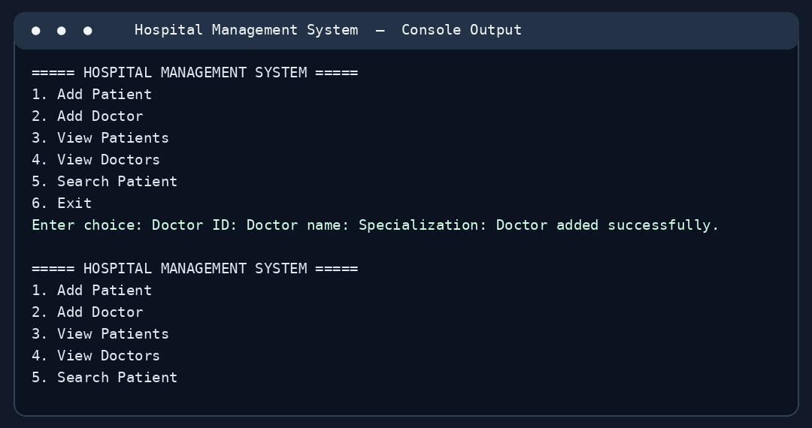
4 View Patients
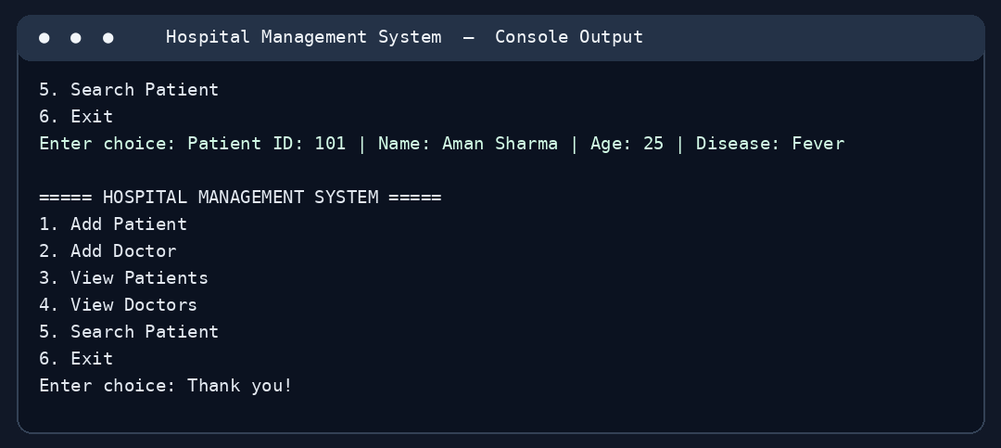
5 View Doctors
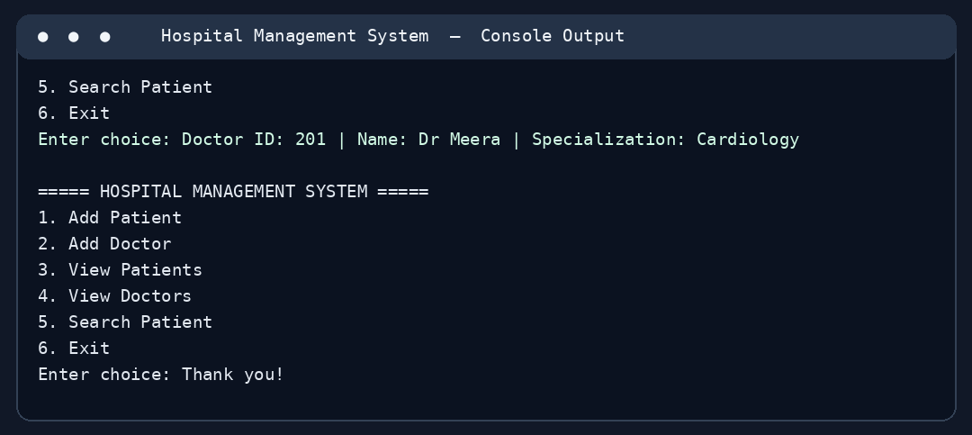
6 Search Patient
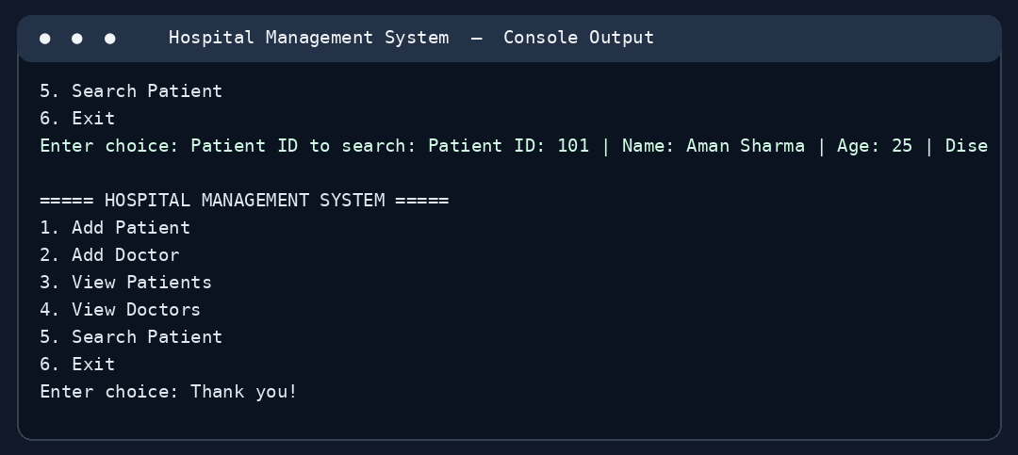
7 Patient Not Found
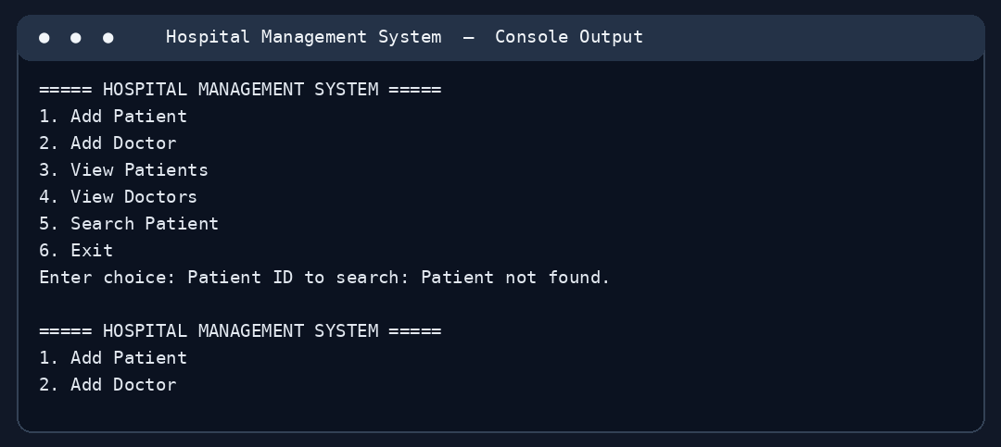
11. Test Cases
Test | Input | Expected Result
Add patient | 101, Aman, 24, Fever | Patient added
Duplicate patient | Patient ID 101 again | Duplicate ID message
Add doctor | 201, Dr Sharma, Cardiology | Doctor added
Search existing | Patient ID 101 | Matching patient shown
Search missing | Patient ID 999 | Patient not found
Invalid choice | 9 | Invalid choice message
Invalid age | -1 | Invalid age message
12. Advantages and Limitations
Advantages: clear modular design, reusable classes, dynamic memory safety using unique_ptr, simple user interface, basic validation, and easy extensibility. Limitations: no database, no appointments or billing, no authentication, and data is lost when the program closes.
13. Future Scope
Future versions could include appointment scheduling, admission/discharge records, billing, pharmacy inventory, file or SQL database storage, role-based login, and a graphical interface.
14. Conclusion
The Hospital Management System demonstrates how C++ OOP principles can be applied to a practical record-management problem. An abstract Person class establishes a common interface, inheritance supports specialized Doctor and Patient classes, and runtime polymorphism displays the correct record type. The project offers a suitable foundation for an expanded hospital information system.
15. How to Run
Compile: g++ -std=c++17 hospital_management.cpp -o hospital_management
Run on Windows: hospital_management.exe
Run on Linux/macOS: ./hospital_management

